**44. Revising AWS Config**

**Overview of AWS Config**

* Aws config primarily used to record the resource configuration changes over time.
* Aws Config continuously monitors and records your AWS resource configurations and allows you to automate the evaluation of recorded configurations against desired configurations.

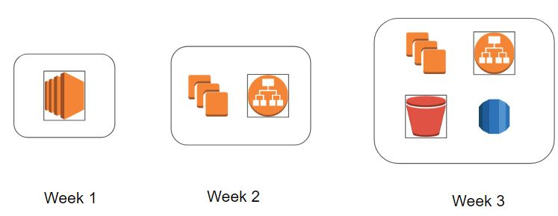

--- **scenario** – An EC2 instance was hosting website from past 90 days. Suddenly in last one week, there have been lot of issues with the requests. What was changed?

in case if you have a config at the infrastructure level, you can easily identify on what are the configuration changes that are being made to the resources. aws config allows you to go ahead and record the resource configuration changes that are being made over time.

**Audit and Compliance**

AWS Config comes with a large set of rules that can continuously monitor your AWS environment and report the findings.  
--- **scenario** - let’s say that you have a rule of approved AMI IDs, so now what AWS config will

Do, any time a EC2 instances launched if that EC2 instance is not created from a specific AMI,

let's say that you have a harden security AMI that all the users are supposed to use and one developer the developer decides to use some different AMI altogether. Then with the AWS config audit rule, you can easily identify that. So, you have a one non-compliant resource so you can easily identify which EC2 instances is not launched from the approved AMI.

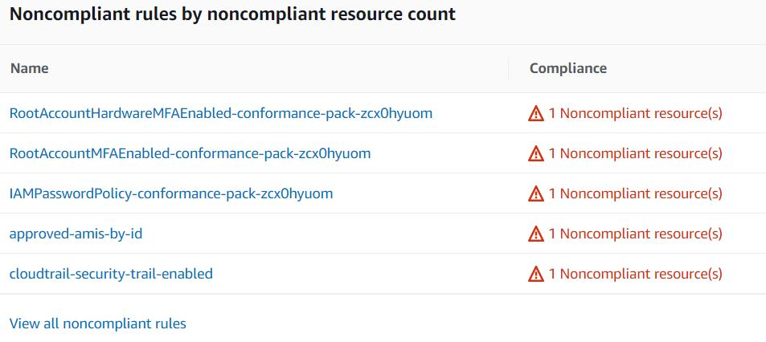

**Pricing of AWS Config**

You pay $0.003 per configuration item recorded in your AWS account per AWS Region. A configuration item is recorded whenever a resource undergoes a configuration change or a relationship change.

Based on rule evaluation. A rule evaluation is recorded every time a resource is evaluated for compliance against an AWS Config rule.

You are charged per conformance pack evaluation in your AWS account per AWS Region based on the tier below.